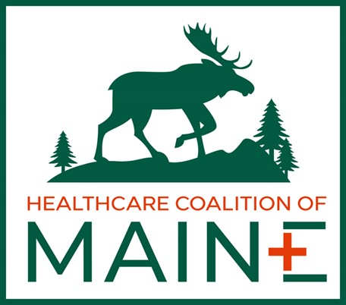 Healthcare Coalition of ME (Steering Committee)
Location: | Zoom (Virtual)
Date: | 02/17/2026
Time: | 10am-11am
Attendees: | Al May, Stacy Boucher, Hannah Dieterich, Andrew Finch (organizer), Alison Dame, Brian Dougher, Danielle Day, David Crowell, Richard Petrie, Brian Peck, Robert Patnaude (if I missed anyone, my apologies)

Meeting Minutes
- Welcome Hannah Dieterich (dee-trick), project manager for HCC
  - Spoke about updates on the website – will be sending out link to website with password
  - Discussed HVA refreshes that she is working on in all districts to have those completed by 06/30/2026 along with training needs assessment that needs to be completed by 03/31/2026
- Andy spoke about MRSE 2026 (med surge exercise)
  - Planned for three districts last year, with some other participants
  - This year Andy wants to finish EMResource pilot with Cumberland by the end March 2026 to implement this resource sharing tool as the focus of the MRSE this year
  - Currently, EMResource is being worked on by Nate R. (communications at PHEP), Kristene Jenkins (DL for Cumberland) and Andy – it needs to fit with ASPR’s online reporting tool
  - Andy wants to improve communication and planning, wants the MRSE to be more of an opportunity to learn from errors, wants it to be more useful to participants
  - MRSE due on 06/30/2026
- Statewide meeting discussion:
  - David: a statewide meeting always makes sense, buildout sharing and resource sharing or what’s available and what’s accessible is important for all provider types
  - Ali: in-person means more participation
  - Richard: host the meeting with a defined goal and objectives (the meeting needs to bring value to participants), what do we want to accomplish, what do we want to leave the meeting with, there needs to be a reason to be there
    - Goals: increase statewide collaboration, coordination, and communication
    - Develop statewide plans and templates that make sense per provider type
    - Put together to help member agencies during disasters, be prepared for all circumstances
  - Al: to get objectives of interest: what does Maine CDC want and need for a conference type meeting and what are the current objectives of Maine CDC?
    - Ask districts to present HVA’s or success stories
    - Look at the workplans and how it meets statewide requirements
    - Breakout groups by area of expertise but also offer alliances and connections
  - EMS presentations/breakout group!
  - Patients with dementia, aging, protocols (breakout group/opportunity to learn more)
  - Andy: need clear tasks and goals during this meeting
- Assessments:
  - Cybersecurity assessment
    - It would be helpful to have someone speak about the impact on the system to give more urgency for facilities to have plans in place
  - Webinars -> Survey -> Templates
    - (This would be a great opportunity to present valuable information and increase engagement both statewide and chapter specific.)
Action items | Owner(s) | Deadline
Set date for website launch | Hannah and Andy | 03/01/2026
Andy to meet with Sharon on MRSE | Andy | 02/18/2026
Survey for wants/needs for statewide conference | Hannah send out and committee answer by: | 03/16/2026
Send out website to steering committee | Hannah | attached to email

